<http://sotd.us/cashmirslaughter/Fundamentals%20of%20Web%20Application/CSlaughter_Webpage_2018.html>

<http://sotd.us/cashmirslaughter/Fundamentals%20of%20Web%20Application/>

Design Your First Homepage/module2

URL to GitHub

<https://github.com/Cashmir/CIS3917_Distributed_Databases>

1.

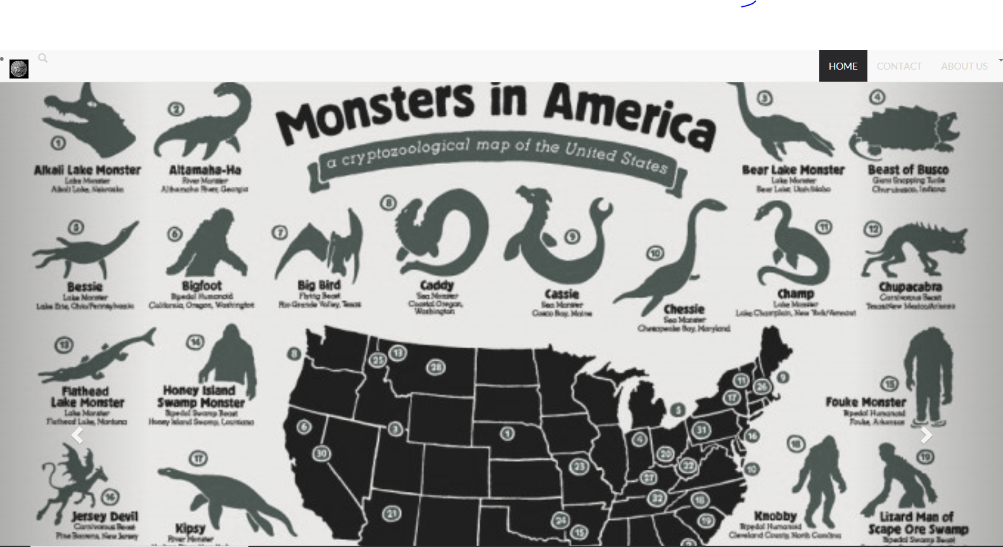

2.

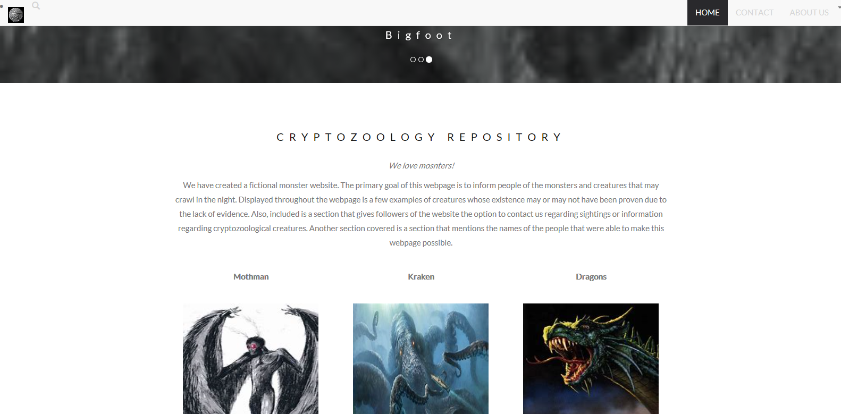

3.

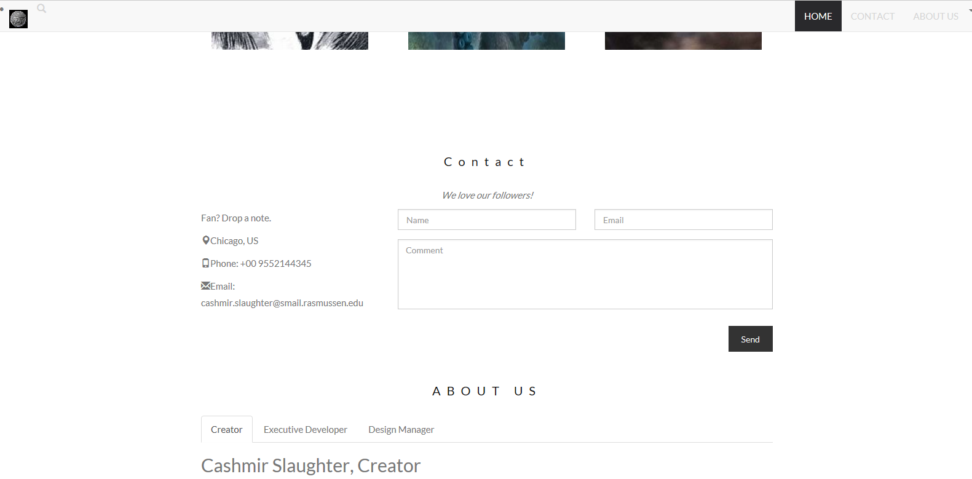

4.

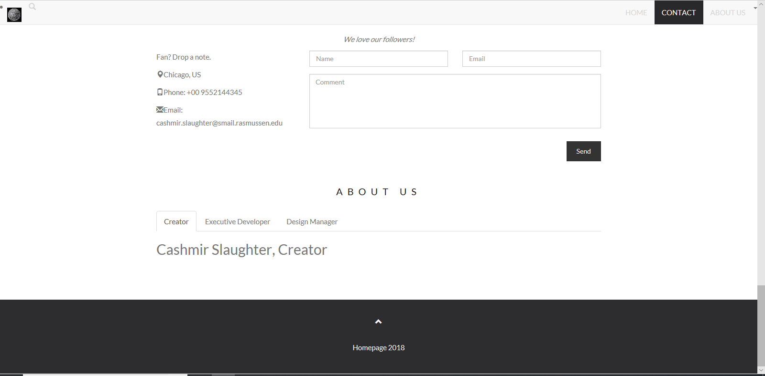

[sftp://bitnami@23.99.179.134/home/bitnami/Fundamentals%20of%20Web%20Application/CSlaughter_Webpage_2018.html](CSlaughter_Webpage_2018.html)